Missouri Department of Natural Resources

LAKE OF THE OZARKS
WATER QUALITY
INITIATIVE
Report
December 2009
Contents
- Executive Summary
- Governor's Charge
- Baseline Survey of Lake of the Ozarks Water Quality
- Inspections and Enforcement of Facilities Discharging into the Lake - Review of Permitting
- Historical and Background Information
- Regulatory Authority at the Lake
- Past Reports and Studies
- Current Lake of the Ozarks Watershed (LOWA) Alliance Study
- Water Quality Survey
- Monitoring Design
- Methodology
- Results/Water Quality Characterization
- Inspection Sweep and Enforcement Activities - Scope and Procedures
- Results
- Follow-up and Enforcement
- Permit Reviews - Land Disturbance Permits
- Construction Permits
- New Permits
- Existing Permits
I. Executive Summary
Governor's Charge
Gov. Nixon directed the Department of Natural Resources (Department) to:
Perform a comprehensive baseline survey of water quality at the Lake of the Ozarks, the results of which were to be submitted to the Governor no later than December 31, 2009. Conduct an inspection sweep of all facilities that held current wastewater permits affecting the Lake of the Ozarks or its major tributaries.
Implement a "zero-tolerance" approach to any violations of the Missouri Clean Water Law or to the conditions of a permit.
Apply the most rigorous standard of review to every application for a water pollution control permit in the Lake of the Ozarks watershed.
Baseline Survey ofLake of the Ozarks Water Quality
The Department collected samples at 78 points throughout the Lake to establish a baseline of the Lake's water quality. The Department then analyzed the samples looking at an extensive range of contaminants. Sample collection and analysis were conducted according to standard procedures set by the U.S. Environmental Protection Agency (EPA).
The Department found sample results indicating elevated bacterial levels at two locations. A low concentration of one Volatile Organic Analyte (VOA) -- n-butylbenzene -- was detected at one location (LC-01). Five pesticide constituents (Atrazine, Cyanazine, Simazine, hexachlorobenzene and hexachlorocyclopentadiene) were detected at very low levels at almost all sampling locations. Of these five, Atrazine was the most frequently detected, however, its levels were below the EPA water quality standard of 3 micrograms per liter. High levels of phosphorus and nitrogen were observed throughout the lake, as well. It should be noted that unseasonably cool and wet conditions during October 2009 led to atypically high flow volume throughout the sample collection period.
Inspection and Enforcement of Facilities Discharging Into the Lake
During the month of October, the Department inspected all 419 active facilities that hold a permit to discharge water into the Lake or listed the Lake as the receiving water in their permit. The Department found 265 of the facilities to be in compliance with the terms of their permits. There were problems found at the remaining 154 facilities. The most common problems were related to disinfection and proper operation and maintenance of the systems. Seventy-five of the facilities with compliance problems took prompt corrective action to resolve their violation(s), and an additional 37 signed agreements to return to compliance by a certain date. The Department initiated enforcement action on a total of 42 facilities.
Stringent Review of Water Pollution Permits in the Lake of the Ozarks Watershed
The Department has instituted stricter permit requirements at the Lake of the Ozarks to ensure the use of the most protective procedures and technologies in all permits for land disturbance activities
and for wastewater treatment facilities. New permits will require more extensive review and will have additional monitoring and reporting requirements.
II. Historical and Background Information
The Lake of the Ozarks was created in 1931 when the Union Electric Company of St. Louis constructed the Bagnell Dam, impounding the Osage River for hydropower generation. Union Electric is now part of the Ameren Corporation. AmerenUE, a subsidiary of Ameren Corporation, owns the dam and the land surrounding the Lake up to an elevation of 660 feet above sea level. The lake level is approximately 658 feet above sea level in the summertime and is drawn down to 654 feet above sea level in the winter. AmerenUE operates the Lake of the Ozarks and Bagnell Dam (Osage Project) under a 40-year license, which was re-issued by the Federal Energy Regulatory Commission (FERC) in 2007.
Regulatory Authority at the Lake
Federal, state and local authorities regulate activities that affect water quality at the Lake. FERC imposes regulatory requirements upon AmerenUE as conditions of their license to operate the Osage Project. A 2005 settlement agreement negotiated in conjunction with the FERC re-licensure process required AmerenUE to develop a shoreline management plan to address development and use of the shoreline at the Lake. This settlement agreement was incorporated into the FERC license. The AmerenUE Shoreline Management Plan (SMP) includes a permitting program to assure compliance with state and federal permitting requirements for activities on project lands and other measures to protect habitat and the environment. AmerenUE's SMP addresses sewer effluent lines that discharge into project waters, stating "Individual wastewater systems are not permitted within the AmerenUE project boundary unless specifically approved by AmerenUE after written recommendation from the County Health Department and/or the Missouri Department of Natural Resources."
Essentially, these requirements reinforce the applicable federal and state requirements. EPA has authority under the Clean Water Act that is delegated to the State of Missouri.
Under Missouri Law (Chapter 701 RSMo.), the Department of Natural Resources has jurisdiction over wastewater systems that discharge 3,000 gallons or more per day. The Missouri Department of Health and Senior Services (DHSS) has responsibility for permitting on-site sewage systems serving single family residences on lots of less than three acres that discharge less than 3,000 gallons per day. Single family residence lots that are three acres or larger are exempted from regulatory requirements under Missouri law, provided that all points of the system are at least 10 feet from any property line and provided no effluent enters an adjoining property, creates a nuisance or contaminates surface or groundwater. This exemption does not apply if the property is adjacent to a lake operated by the U.S. Army Corps of Engineers or by a public utility, such as AmerenUE.
Benton, Camden and Morgan Counties have established ordinances that govern permitting, inspections and enforcement of single family on-site systems within their jurisdictions and have signed agreements with DHSS. In Miller County, DHSS performs these functions.
Previous Reports and Studies
As early as 1981, water quality at the Lake of the Ozarks was a subject of concern and scrutiny. A variety of parties, including the State, local governments, and private entities have completed water quality studies and reports over the past three decades in order to assess the Lake including, specifically, contamination related to inadequate wastewater treatment. By and large, the studies concluded that continued development around the Lake, absent effective steps to address wastewater treatment, could cause a decline in water quality or at least produce periodic water quality problems.
In August 1985, the Department published An Engineering Geologic Approach to Evaluating Groundwater and Surface-Water Contamination at Lake of the Ozarks, Missouri. The purpose of the report was to describe and classify groundwater resources and engineering characteristics of area soils and bedrock with respect to land development and waste disposal. The report concluded that the thin soils and steep slopes surrounding much of the Lake present "moderate to severe" limitations with respect to on-site waste disposal systems. These geological features allow high rates of surface runoff and rapid shallow groundwater flow, increasing the risk that septic tank effluent could reach the Lake or nearby drinking water wells before all bacteriological contaminants are removed.
In 1996, a group composed of municipal, county, state and Lake area business stakeholders commissioned a plan to evaluate the feasibility of creating a Lake-wide water and wastewater district. Its 1999 report recognized the impacts development could have on the Lake's water quality and cautioned that the Lake area's projected population growth could only exacerbate existing problems. The report echoed the Department's earlier finding that geologic conditions around the Lake are not suited for on-site wastewater treatment systems. The report estimated that there were 15,000 to 20,000 on-site treatment systems existing around the Lake at that time. The report's authors concluded that the four counties should establish a regional water and wastewater district. The report recommended further actions should be taken to develop funding options, pursue enabling legislation and develop a comprehensive master plan that included public involvement.
Ongoing Lake of the Ozarks Watershed Alliance (LOWA) Study
AmerenUE agreed to provide funding for a five-year study of bacterial levels in Lake coves as a condition of the Section 401 Water Quality Certification issued by the Department as part of the FERC licensing process. Past sampling had identified fecal coliform levels in excess of state standards following substantial rain events. FERC ordered AmerenUE to conduct cove sampling in an effort to identify "areas of concern that may degrade water quality" at the Lake. This study is a five-year cooperative effort by Department and LOWA. The plan includes collecting samples from the entire length of the Lake from Bagnell Dam to Harry S Truman Dam over the five-year period. Each year, approximately 30 coves are sampled monthly during the recreational season (May to October); each cove is planned to be sampled every other month. The Department provides training to LOWA volunteers, who collect the water samples. Samples are then analyzed by the Department's laboratory using methods approved by the EPA. All samples are analyzed for Escherichia coliform bacteria (E. coli).
Since the beginning of the study in 2007, 1,012 samples have been collected and analyzed. The annual and three-year geometric means have been below the State Water Quality Standard geometri
mean of 126 cells/100 ml; approximately 4 percent of the samples exceeded the EPA's recommended single-sample maximum criteria for whole-body contact recreation at designated swimming areas (235 E. coli colonies / 100 ml). Each year of the survey, the E. coli levels were highest in the spring, when precipitation and runoff were greatest and trended downward throughout the summer (See Figure 1 below).
Monthly e. Coll levels
May June July August September October

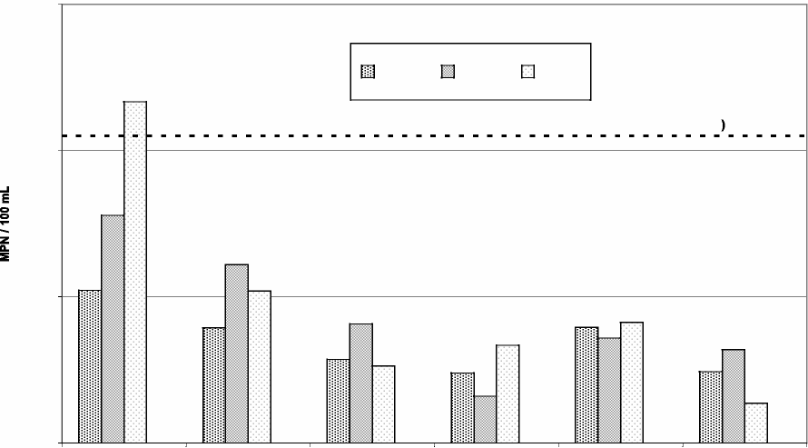
1000.0
100.0
10.0
1.0
2007 2008 2009
Criteria Limit (126 MPN/100 mL
Month Sampled
Figure 1. Monthly E coli Levels from samples collected by LOWA, 2007-2009
III. October 2009 Water Quality Survey
Monitoring Design
The objective of the Lake of the Ozarks survey was to develop a comprehensive baseline study of water quality at the Lake. The Department collected surface water samples at each of 78 points in the Lake. All samples were collected during the month of October.
The study area included the main channel of Lake of the Ozarks from Bagnell Dam to Harry S Truman Dam as well as each major tributary that enters the Lake and several other coves and minor tributaries. Figure 2 depicts the 78 sampling locations. These were chosen to include points in the main channel, near large coves, near large marinas, near wastewater treatment outflows and in both developed and undeveloped regions.
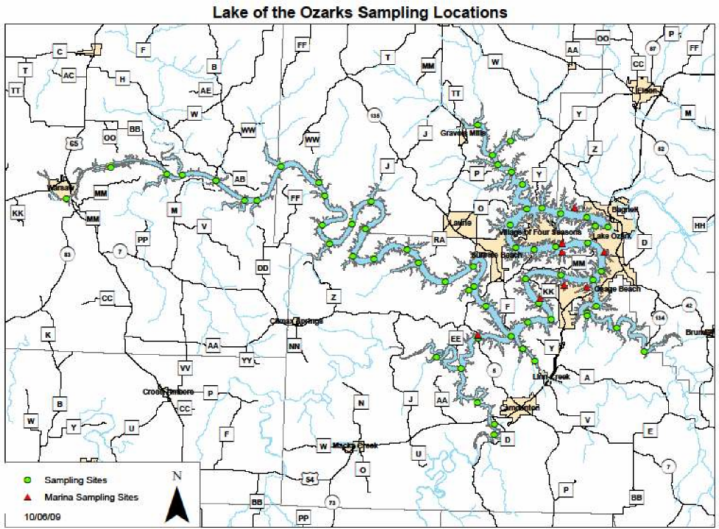

Figure 2. Lake of the Ozarks Sampling Locations
A baseline water quality study of a water body normally involves repeated sampling at set intervals throughout an entire year so that seasonal variability in water quality can be assessed. At least one additional round of sampling at another time of the year would further enhance our water quality survey at the Lake of the Ozarks. Variables such as lake stratification, precipitation, ambient temperatures and weather conditions, inflow from tributaries, and releases from Bagnell Dam and Harry S Truman Dam can influence any sampling results at the Lake. The National Weather Service reported that unseasonably cool and wet conditions prevailed throughout much of October, with precipitation totals five to eight inches above normal and average temperatures well below normal.
Methodology
Samples were collected over a 10-day period beginning October 12 and ending October 21, 2009. Collection activities began near Bagnell Dam and progressed up the lake towards Truman Dam.
Sample collection and analysis was performed in accordance with the Department's standard operating procedures and were consistent with project guidelines contained in the Fiscal Year 2010 Quality Assurance Project Plan for E. coli Monitoring for Lake of the Ozarks (QAPP).
Results / Water Quality Characterization
This section summarizes the analytical results for each water quality parameter tested during the Lake of the Ozarks water quality survey. An interactive map showing sample locations and corresponding water quality data is available on the Department's Web site at dnr.mo.gov/loz.htm#initiative.
Escherichia coliform bacteria (E. coli) — Coliform bacteria are a collection of microorganisms
that live in large numbers in the intestines of warm-blooded animals including humans and birds. A specific subgroup of coliform bacteria is fecal coliform bacteria, the most common member being Escherichia coli. Organisms such as E. coli bacteria usually do not cause disease but their presence may indicate that other microbial pathogens are in present in water. Only a few types of E. coli cause sickness.
Unlike most chemical contaminants, bacteria tend not to distribute evenly in water and concentrations can vary from day to day due to movement in or out of the water column, movement of the water carrying the bacteria, mortality or other variables. This can cause bacterial counts to vary widely throughout the Lake. Often, a significant amount of variability can exist within a single cove.
The EPA guidance for a single sample at a public swimming beach is 235 MPN/100 Milliliters. Two of the 78 locations sampled during this study had E. coli concentrations above these levels.
(See Figure 3.) They were located in the upper areas of the Grand Glaize and Little Niangua arms of the Osage River.
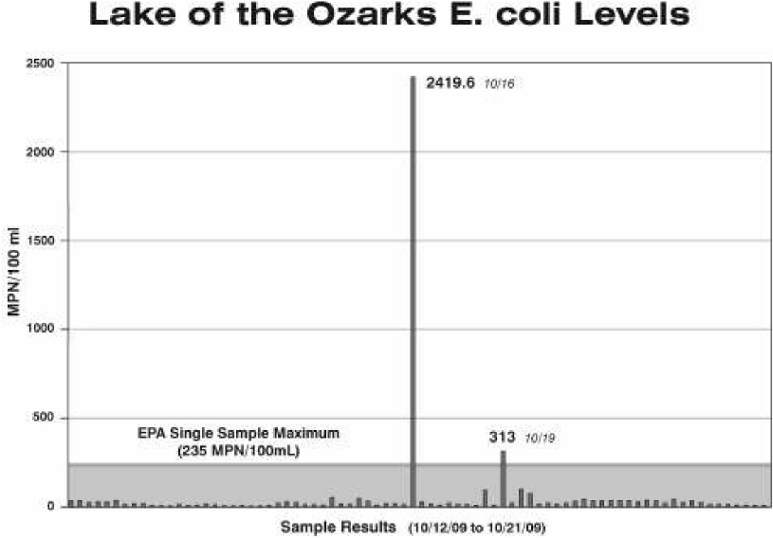
Figure 3. Lake of the Ozarks E. coli levels
8
Volatile Organic Analytes (VOAs) — VOAs are organic chemicals that evaporate at relatively low temperatures and thus are considered highly volatile. They are found in a variety of commonly used products such as gasoline, adhesives, paints, refrigerants and dry cleaning fluids. Of the 78 locations sampled, a low concentration of one VOA -- n-butylbenzene -was detected at one location (LC-01). This was below the EPA and Missouri water quality standard. No other VOAs were detected in the survey.
Petroleum Fractions (OA2) — Petroleum fractions are low volatility chemicals present in petroleum products such as mineral spirits, kerosene, diesel fuel, fuel oil, motor oil and hydraulic fluid. Petroleum fraction constituents were not detected in any of the samples collected.
EPA Method 507/508 Pesticides — Pesticides include any chemical designed to kill or control weeds or animal pests. The term 507/508 Pesticides specifically refers to nitrogen-containing, phosphorous-containing and organochlorine-type pesticides that are commonly used for agricultural and residential purposes. Five pesticide constituents (Atrazine, Cyanazine, Simazine, hexachlorobenzene and hexachlorocyclopentadiene) were detected at very low levels at almost all sampling locations. Of these five, Atrazine was the most frequently detected, however, its levels were below the EPA water quality standard of 3 micrograms per liter.
Total Nitrogen - Total Nitrogen in water is composed of ammonia, nitrate, nitrite and organic nitrogen. Total Nitrogen levels exceeded the Missouri water quality standard at most sampling locations at Lake of the Ozarks. There are many potential sources of nitrogen within the watershed. Total Nitrogen concentrations were lowest near Bagnell Dam and highest closest to Harry S Truman Dam. (See Figure 4.).
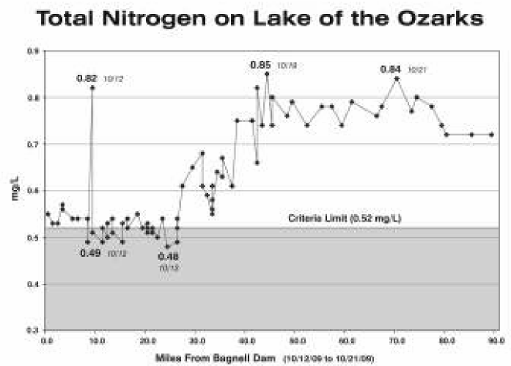

Figure 4. Total Nitrogen on the Lake of the Ozarks

Total Phosphorus — Total phosphorus in water is composed of organic phosphate, inorganic phosphate and orthophosphate. Phosphorus is a necessary nutrient required for plant (or algae) growth and can limit plant growth in fresh water systems. Total Phosphorus levels exceeded the Missouri water quality standard at all locations sampled for this study. There are many potential sources of phosphorus within the watershed and the sampling occurred during times when runoff was high because of recent rainfall events. Like Total Nitrogen, Total Phosphorous concentrations were lowest near Bagnell Dam and highest closest to Harry S Truman Dam. (See Figure 5.)
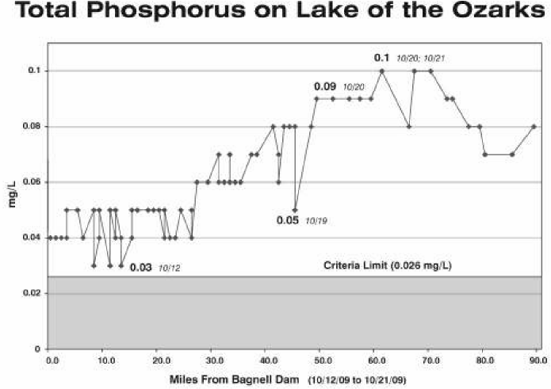
Figure 5. Total Phosphorus on the Lake of the Ozarks
Chloride — Chloride is a component of many types of salt resulting from the combination of chlorine and a metal, such as sodium, forming sodium chloride (NaCl - common table salt). Dissolved chlorides are not usually harmful to people, but elevated chloride concentrations often indicate human activity in the area. Chloride concentrations at all sample locations were below the Missouri water quality standard of 860 milligrams per liter and are considered normal.
pH — The pH of a water body is a measure of the ratio of hydrogen to hydroxide ions. A pH of seven indicates this ion ratio is balanced, or "neutral." When hydrogen ions increase, the water becomes more acidic and the pH falls below seven. Conversely, when hydroxide ions increase, the water becomes more alkaline and pH increases to above seven. Missouri water quality
standards specify a pH range of 6.5 to 9.0. The pH at all sample locations was within this range.
Total Alkalinity as CaCO3 — The alkalinity or buffering capacity of water refers to how well it can neutralize acidic pollution and resist changes in pH. Alkalinity is a measurement of carbonates, bicarbonates and hydroxides concentrations. The alkalinity at all sample locations was considered normal.
Non-Filterable Residue (NFR) — NFR refers to suspended particles that can be removed from water by a 0.2 micron pore-diameter filter. NFR include an inorganic fraction (silts and clays) and an organic fraction (algae, zooplankton, bacteria, and detritus), both of which contribute to water turbidity. These suspended particles become sediments when they settle to the bottom of a water body. The NFR at all sample locations was below levels that would indicate poor water quality.
Turbidity — Turbidity is a measure of the cloudiness of water that is caused by suspended solids. Moderate turbidity levels may indicate a healthy lake ecosystem, but higher levels of turbidity are usually indicative of poor water quality. The turbidity levels at all sample locations were within the acceptable range.
Temperature — Water temperature affects the solubility and, in turn, the toxicity of many contaminants. Generally, solids are more soluble in warm water, whereas gases tend to be more soluble in cold water. An inverse relationship exists between water temperature and the amount of dissolved oxygen present in a lake. As lake water warms, dissolved oxygen levels tend to decrease. Temperature at all sample locations was consistent with the temperature expected at the time of year of sampling.
Dissolved Oxygen — Dissolved oxygen is a requirement for the metabolism of aerobic organisms such as fish. Oxygen can enter lake water by diffusion from the surrounding air, by aeration (wave action) and as a product of photosynthesis. Dissolved oxygen levels at all sample locations were high enough to support aquatic life.
Specific Conductivity — Specific conductance measures the ability of water to conduct an electrical current. It tends to indicate the amount of dissolved material present in water. Specifi conductivity at all sample locations did not indicate any areas of concern.
IV. Inspection Sweep and Enforcement Activities Scope and Procedures
The Department conducted an inspection at each permitted wastewater facility that discharges to the Lake of the Ozarks, including facilities that discharge directly into the Lake and also those that discharge into a major tributary of the Lake. There are 421 such facilities. Two of these permitted facilities were no longer operating, hence their discharge permits were terminated, reducing the total inspection list to 419. Inspections and follow-up actions were conducted in accordance with the Department procedures.
Department staff reviewed the operational features of wastewater treatment plants to determine if the plants were functioning according to their designs. The inspectors examined the physical components of the treatment works, such as basins and pipes, the power supply, motors and pumps.
Inspectors also reviewed the level of maintenance at each facility, checked fencing, weed control and physical conditions, such as rust and corrosion. They surveyed the facility's treatment supplies, such as chlorine and other chemicals, to determine if they were available and being applied. In cases where treatment plants were discharging at the time of the inspection, the inspectors collected
samples for analysis in the Department's laboratory to determine if the plant was providing adequate treatment.
If the owner or operator was present at the time of the inspection, they were immediately informed of the violations, if any. If sampling results revealed additional violations, owners or operators were typically notified within two weeks following the inspection.
The Department promptly mailed inspection reports to the owners and/or operators of each permitted facility. Reports transmitting a Notice of Violation (NOV) or Letter of Warning (LOW) were, in most cases, sent the day following the inspection. All other reports were mailed within three to 14 days.
The Department generally issues LOWs for first-time or minor violations; NOVs are issued when serious, potentially serious or repeated violations are found. In both situations, the violator is required to take specific actions to ensure that they return to compliance. Timeframes for returning to compliance vary according to the seriousness of the violation. The Department conducted follow- up inspections where needed, and enforcement actions were taken to address violations that were not promptly corrected. A facility was returned to compliance once the Department determined that it had corrected the violation(s) identified during the inspection.
Results
Of the 419 facilities inspected during the Lake of the Ozarks sweep, 63 percent were found to be in compliance with the conditions of their permits. About 37 percent of the facilities had some violation that resulted in the issuance of a LOW or NOV. A total of 208 separate violations were identified at 154 facilities during the sweep. These are shown in Table 1. Violations were identified at 130 of the facilities at the time of the inspection, with 82 notices of violation and 48 letters of warning issued. The Department analyzed wastewater discharge samples and found that 44 facilities did not meet permitted limits, and these facilities were issued 20 NOVs and 24 LOWs. Twenty-two of these facilities had been cited for violations at the time of the inspection. The most common and serious violations were related to disinfection of wastewater. More than 40 percent of the facilities with violations had some problem related to disinfection.
Table 1. Violations Identified during Inspection Sweep
Violation | Description | Violations Cited
Effluent Quality | Effluent quality exceeded permitted limits | 44
No/nonfunctioning Disinfection | Chlorinator, dechlorinator or ultraviolet unit not operational | 34
Unapproved Disinfection | Non-standard chlorinators or dechlorinators | 32
Operation and Maintenance Issues | Various operation and maintenance issues | 29
Permitting Issues | Construction or operation without a | 19

 | permit, failure to submit proper permit paperwork.
Schedule of Compliance Issues | Failed to comply with permit schedule of compliance | 16
Discharge Monitoring Report Issues | Missing reports or discharge monitoring report exceedances | 12
Design Guide/Engineering Issues | Structural, sizing, component issues | 12
Discharge Appearance Issues | Solids in discharge or stream, general poor effluent appearance | 10

Wastewater samples were collected at 204 facilities that were discharging at the time of inspections. These samples were analyzed for the discharge permit parameters of Biochemical Oxygen Demand (BOD), Total Suspended Solids (TSS) and Fecal Coliform. These are the parameters currently limited in wastewater discharge permits at Lake of the Ozarks. Samples were also analyzed for E. colt. Department staff reviewed the sampling results and issued NOVs and LOWs for violations of the permitted limits. These NOVs and LOWs were in addition to any inspection violation notices that had been sent to the facilities following the inspection. Facilities that were found to be out of compliance during inspection due to malfunctioning or improperly designed disinfection equipment were most likely to yield sample results with unacceptable concentrations of BOD, TSS or fecal coliform.
Given the clear link between disinfection system functionality and effluent quality, the Department required facilities to correct malfunctioning disinfection equipment immediately or to enter into schedules of compliance. If the facility failed to do so, the facility was referred for further enforcement.
Twenty three inspected facilities showed effluent violations with no obvious operational problems found during the inspection. These facilities will also be re-inspected at the start of the 2010 recreational season.
Follow-up and Enforcement
Parties in violation were given seven days to respond to the inspection report with a response indicating a remedy or a commitment to fix the problem in a timely manner. If corrective action could not feasibly be achieved within seven days, a schedule of compliance was drafted by the Department. These compliance schedules require the permit holder to complete all necessary corrective actions prior to the beginning of the recreational season on April 1, 2010.
Forty-one facilities failed to achieve compliance through immediate action and did not accept a schedule of compliance to make improvements related to the violations. These cases were reviewed by the Department's enforcement staff, and responsible parties were offered the opportunity to settle the violations by accepting an Abatement Order on Consent (AOC). These AOCs contained an upfront penalty for the violation and a schedule of compliance stipulating further penalties if the facility failed to complete the necessary work. The facilities were given one week to respond to the proposed AOCs by either accepting the AOC or making a counteroffer. If a facility did not accept the order or reach an alternative resolution that addressed the violations, the Department referred the matter to the Attorney General's Office to initiate litigation. Through Dec. 28, seven facilities were
referred to the Attorney General's Office, and three facilities had signed abatement orders on consent.
At the outset of the initiative, the Department already had four enforcement cases underway in the Lake of the Ozarks area. These cases were included in the initiative as staff conducted additional inspections and confirmed the violations.
V. Permit Reviews
The Department enacted the following procedural changes under existing regulations on October 1, 2009 as a part of the Lake of the Ozarks Water Quality Initiative.
Land Disturbance Permits
All applicants for land disturbance permits are required to develop a storm water pollution prevention plan. This plan is the primary requirement of the permit in that it specifies measures to minimize the amount of sediment leaving the site. In order to ensure protection of the Lake of the Ozarks, applicants must now submit the plan with their permit application for Department review and approval or denial. The Department will return as deficient all applications with plans that do not include adequate protections. Processing of the permit will resume when an appropriate plan is submitted. The Department will inspect each site upon issuance of the permit to evaluate the applicant's implementation of the plan.
Construction Permits
The Department reviews wastewater construction permit engineering plans, specifications, and reports in accordance with the guidelines presented in the Missouri regulations 10 CSR 20 Chapter 8. Where deviations occur that require some interpretation of the regulation, the Department will ensure that the applicant is held to the most environmentally protective interpretation. The Department will require the applicant to submit an evaluation of the effectiveness of the technology with the permit application for the Department's approval.
New Operating Permits
Before issuing new Missouri Operating Permits for discharges into the Lake of the Ozarks, the Department ensures permits are written to protect the water quality of the Lake. Parameters necessary to ensure this include BOD, TSS, pH, fecal coliform, Ammonia, Total Residual Chlorine (or ultra-violet disinfection when applicable), and Temperature. The Department is developing nutrient limits and monitoring implementation guidance for these permits in response to recently promulgated nutrient water quality criteria for lakes. The Department will ensure that the effluent limits are protective through the anti-degradation review process.
xisting Permits
During the inspections conducted at the Lake of the Ozarks, Department inspectors ensured that each facility had a valid Missouri State Operating Permit (MSOP). If the facility did not have a valid permit, the Department issued a Notice of Violation and required the facility to submit a complete
application to renew the permit within seven days. As existing permits are renewed, the Department will incorporate the more stringent requirements that have been implemented for new facilities as a part of the Lake of the Ozarks Water Quality Initiative.

